Multiple choice section

|  |  |  |  |  |  |  |  |  |  |  |
| --- | --- | --- | --- | --- | --- | --- | --- | --- | --- | --- |
| Question | 1 | 2 | 3 | 4 | 5 | 6 | 7 | 8 | 9 | 10 |
| Answer | D | A | C | A | B | D | C | B | A | B |

Question 1 [7.3]

D

÷ 6 and × 6 are inverse operations.

Question 2 [7.3]

A



Question 3 [7.1]

C

2 × 8 = __ + 6

16 = 10 + 6

Question 4 [7.2]

A

2n + 4 = 10

Question 5 [7.5]

B



Question 6 [7.2]

D



Question 7 [7.3]

C

Multiply both sides by 5 to remove the denominator from the LHS.

Question 8 [7.4]

B



Question 9 [7.4]

A



Question 10 [7.2]

B

t + 2 = 5

Multiple-choice total marks: 10

Short answer section

Question 11 3 marks [7.3, 7.4]

(a) When backtracking, we undo an operation by using the inverse operation.

(b) To solve an equation is to find the value of the unknown.

(c)  and  are equivalent equations

Question 12 2 marks [7.3]

The process of checking by substitution is to check that the answer obtained is the solution to the equation by substituting it back into the original equation. If the LHS equals the RHS, the answer is the solution.

Question 13 3 marks [7.1]

|  |  |  |
| --- | --- | --- |
| (a) 4 + 5 × 2 = 14 ≠ 18 False | (b) 29 – 8 = 21 ≠ 28 False | (c) 10 × 4 = 40 =  True |

Question 14 2 marks [7.1]

(a) 6 + 75 = 81

(b) 

Question 15 1 mark [7.1]

142 + 15 = 157

Question 16 3 marks [7.2]

(a) y plus eight is equal to twelve

(b) a divided by ten is equal to five

(c) four multiplied by x is equal to twenty-eight

Question 17 2 marks [7.2]

|  |  |
| --- | --- |
| (a) Substitute b = 3 into b + 9: 3 + 9 = 12 Yes | (b) Substitute x = 84 into :    No |

Question 18 2 marks [7.3]

(a) 3x + 4 = 31 (b) x = 9

Question 19 2 marks [7.3]

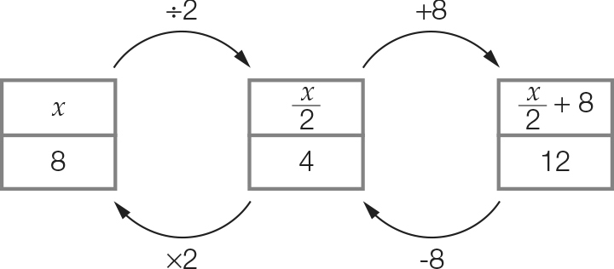

x = 8

Question 20 4 marks [7.4]

(a)   
  


(b)   
  
  


Question 21 2 marks [7.3]

3n + 2 = 17

3n = 15

n = 5

Question 22 2 marks [7.4]

(a) The right-hand side is heavier.

(b) Take two apples from the right-hand side.

Question 23 6 marks [7.4]

(a) x + 9 = 12 (+ 6)  
Add 6 to both sides of the equation to form an equivalent equation.  
x + 9 + 6 = 12 + 6  
x + 15 = 18  
Check the solutions to both equations.  
Old x = 3; New x = 3

(b) x – 11 = 14 (+ 4)  
Add 4 to both sides of the equation.  
x – 11 + 4 = 14 + 4  
x – 7 = 18  
Check the solutions to both equations.  
Old x = 25; New = 25

(c) x – 7 = 3 (– 9)  
Subtract 9 from both sides of the equation.  
x – 7 – 9 = 3 – 9  
x – 16 = -6  
Check the solutions to both equations.  
Old x = 10; New x = 10

Question 24 4 marks [7.4]

(a) 6x + 2 = 26  
6x + 2 – 2 = 26 – 2  
6x = 24  
6x ÷ 6 = 24 ÷ 6  
x = 4

(b)   
  
  
  


Question 25 3 marks [7.5]

P = 2l + 2w

56 = 2(3w) + 2(w)

56 = 6w + 2w

56 = 8w

w = 7 cm

l = 7 × 3 = 21 cm

Question 26 2 marks [7.5]

(a) 250 – 58 = 2n or 2n + 58 = 250

(b) 250 – 58 = 2n  
192 = 2n  
n = 96  
Each pair of jeans cost $96.

Short answer total: 44

Extended answer section

Question 27 4 marks [7.5]

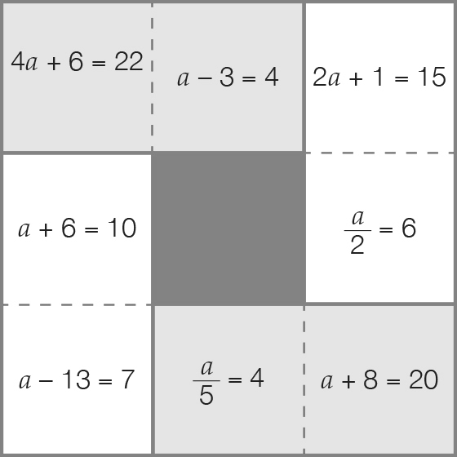

Question 28 6 marks [7.5]

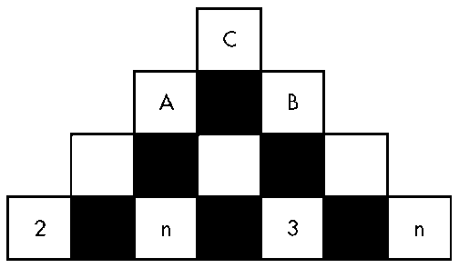

(a) A: 2 + n + n + 3 = 2n + 5  
B: n + 3 + 3+ n = 2n + 6  
C: 2n + 5 + 2n + 6 = 4n + 11

(b) 4n + 11 = 27

(c) 4n + 11 = 27  
4n + 11 – 11 = 27 – 11  
4n = 16  
n = 4  
Substituting n = 4 into the expression 4n + 11 to find c, 4 × 4 + 11 = 27  
Substituting n = 4 into the expression 2n + 6 to find b, 2 × 4 + 6 = 14  
Substituting n = 4 into the expression 2n + 5 to find a, 2 × 4 + 5 = 13  
To check c = a + b; 27 = 14 + 13 is a true number sentence.

Extended answer total: 10

TOTAL test marks: 64